July Meeting
Date: 07/20/26

Attendees:
- Jeffrey Mauras (President)
- Hannah Breckwoldt (Secretary)
- Rebecca Maitski (Webmaster)
- Tedrick Mangassarin (Social Chair)
- Colby Vinson (President Elect)
- Kimia Roghani
- Michael Steadman
- Adel Shalabi
- Lily Valiulis

Introductory information to introduce HSA, new committee members and explain our role as an organization and how we can help with various issues or concerns brought up by residents

Introduction of New Committee Members
- President: Jeffrey Mauras
- President elect: Colby Vinson
- New HSA flyer with QR code for easy access- on display at resident onboarding
- Secretary: Hannah Breckwoldt
- Webmaster: Rebecca Maitski
- New Instagram page, everyone give it a follow! (@lsuhschousestaffassociation)
- LSU HSA website updated (https://residents.lsuhsc.edu/nohsa/default.aspx)
- Social Chair: Tedrick Mangassarin
- DEI subcommittee representative: Michelle Li
- Will attend the GME Engagement and Health Equity subcommittee meetings and will relay information

House Staff Association Email: Housestaffassn@lsuhsc.edu
- Thank you to Treva Durr for getting all the new committee members access to the HSA email. Members will check the email frequently to ensure timely responses to any emails regarding ongoing questions/concerns

Introduction of new HSA Liaisons:
- Family Medicine Bogalusa- Sophie Palopoli PGY-1
- LSU Internal Medicine- Adel Shalabi PGY-1
- Urology- Clara Puente PGY-2
- Anesthesia- Lily Valiulis PGY-1
- OB/GYN- Michael Steadman PGY-1
- Psychiatry- Kimia Roghani PGY-1

Recent meetings attended by HSA President (Jeffrey Mauras) to introduce HSA and explain our role
- Urology orientation- 6/25
- Neurology didactics- 7/16

Ongoing issues that have been brought up:
- Resident Parking at Children’s Hospital
- Spoke with LSU residency leadership who escalated to hospital leadership
- Confirmed that residents are still not allowed to park in the Children’s Parking Garage
- Residents can park in parking lots labeled in light blue in the picture below
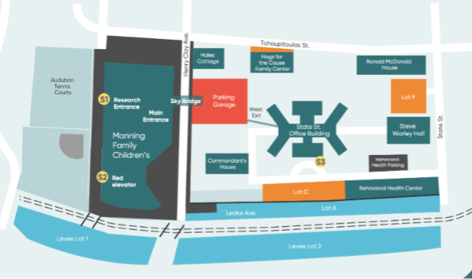
- Children’s also has an overflow parking lot with shuttle service to and from the parking lot to main campus.
- Address to overflow parking lot: 1040 Calhoun St, New Orleans, LA 70118
- You also can request a security escort with the number below
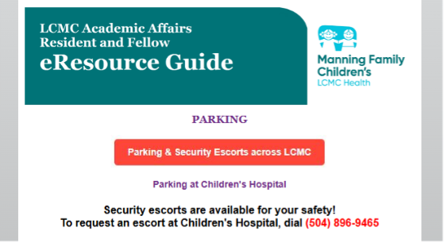

Looking forward to plan fall and spring social
- Discussed options for events in the fall. Discussed possible event at various sites including the Batture as well as different restaurants and breweries
- Will discuss further at future meetings
- Plan to repeat spring social playing pickleball as this was successful last year and residents seemed to really enjoy it

Will plan for an HSA meeting every other month to touch base on any questions/concerns that were brought to HSA’s attention

President (Jeffrey Mauras) meets every month with GMEC for administrative and LSU updates. He also can bring up any questions/concerns as well as provide any big HSA updates during these meetings

